# Instructor Note

This is the instructor’s guide for delivering the Excel and Census Data workshop. It is modular and is meant to be broken up into small parts, delivered either live or recorded. This course is using Excel 2016 for Windows. Many of the tools are specific to Excel for Windows, so if you have attendees using a Mac, they should still use the Excel Windows version using either Basecamp or Parallels.

In terms of using this guide, items in *italics* are meant to be instructions done in Excel or on the Census website. Screen shots appear where they may be useful, with annotations to show you where to click, what to delete, etc.

# Introduction

The U.S. Census Bureau’s mission is to serve as the leading source of quality data about the nation’s people and economy. Whether you are looking for the most current economic indicators or for demographic and socioeconomic characteristics about your community and how they compare statistically to other areas, data from the U.S. Census Bureau are available online through a variety of tools.

Every year, the Census Bureau publishes population, socioeconomic, housing and business statistics for all communities in the country. These data can be sorted by several characteristics such as age, sex and race, as well as different levels of geographies from the nation to areas below cities and towns. They can be charted, compared with other data (from inside or outside Census), and can be used to derive insights about the nation’s characteristics.

# Excel is a tool that many people are familiar with, and many people use every day. Excel can be leveraged to unlock the value of open data of all kinds, and it is particularly well-suited to transforming, analyzing, and visualizing Census data. This course will show how to use Excel to access, manipulate, and visualize Census data. It will also cover mapping that data, and tools for doing advanced statistical analysis.

# Basic Census Data Access

One very easy way to find basic data is by browsing the Community Facts feature found in the American Fact Finder (AFF). American Fact Finder itself is an online, self-service tool designed to search a variety of population, economic, geographic, housing, education, and other types of data. It is a very easy way to look for the data you may need.

The Community Facts section shows you popular tables. You can use the Guided Search feature to narrow down what you are looking for and have AFF suggest datasets for you. You can use the Advanced Search feature (which we will explore later) to build a query for your search. In all cases, the data can be modified prior to being downloaded. We will start with the Community Facts to find our data.

Let’s say we simply want to see the population growth (or decline) of every county in the US over the last 6 years.

*Open* <http://census.gov> *in your browser.*

*On the menu bar at the top, click on Data, and then go to Data Tools & Apps*

*Select American Fact Finder, and click on Community Facts on the menu bar*

*In AFF, look at the options you have on the left to find the data you are looking for*

*We want population data, so choose population.*

Note that at the top, shaded in blue, you can see very common queries presented as a number for the geography you may be looking for. In the case below, it is the Census 2010 Total Population. You can select other common demographic data from the drop down. But in this case, we want several years of population estimates.

*Select Annual Population Estimates*

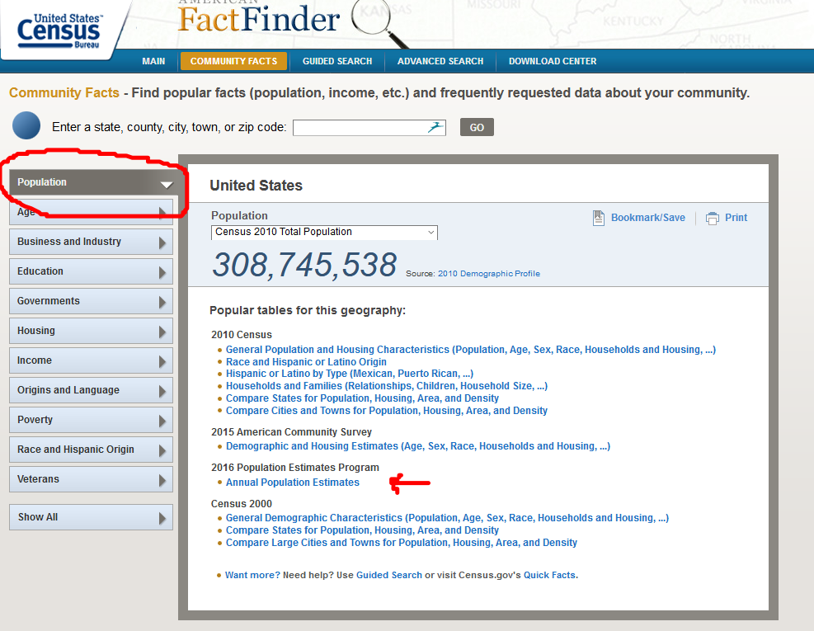

This will bring up a view of the table, and this is the table that we will open in Excel. One of the nice features of this view is that you can modify the table before you even download it into Excel. These are modifications that you can do in Excel after you download it as well, but sometimes it is nice to have less data to download. We will make some modifications in this view, and the rest of the transformation we can do in Excel.

Another way to search for data is to use the Advanced Search feature.

# Data Transformation

One of the many benefits of using Excel is that it can be used to easily transform your data. In this case, we are going to start modifying our table using the Census tools, and then we will put the finishing touches on the structure using Excel. You can do all of this in Excel, but this example shows you useful methods for using both.

You should now be seeing the table with April 2010 census data, and yearly population estimates. Let’s say that we only want to download the yearly population estimates.

*Click on the Modify Table button*

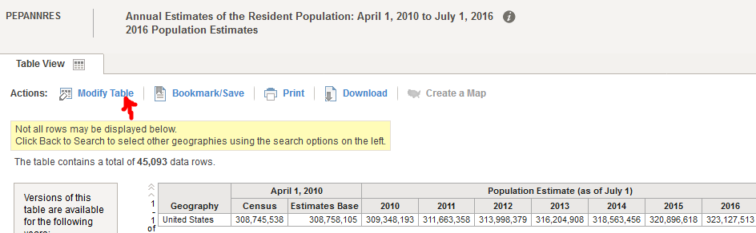

*Uncheck the April 1, 2010 Census and the Estimate base check boxes to modify the table.*

*We will do the rest of the transformations in Excel, so click on Download.*

*Choose “Use” and keep the Merge Annotations and Include Descriptive Elements checked.*

*This will prepare the file for download to a zip file.*

*Click Download*

*Unzip the file called PEP_2016_PEPANNRES_with_ann.csv*

It is a best practice to get in the habit of saving your CSV files as an Excel Workbook right away. This will avoid you wondering later why all the features of an Excel workbook are not available to you.

*Click on File/Save As, and choose the Excel Workbook (usually the top option).*

*Name this file “Population”*

If you expand the columns in this spreadsheet, you will see right away that there are some columns and at least two rows we will not be using. For example, the first two columns are geographic IDs. We won’t be using those, so it makes sense to delete them. There is a top row with field names that we won’t be using, so it makes sense to delete that.

*Delete columns A and B with the geography IDs*

*Delete first row with the Field Names.*

*Delete the row with the total United States population information*

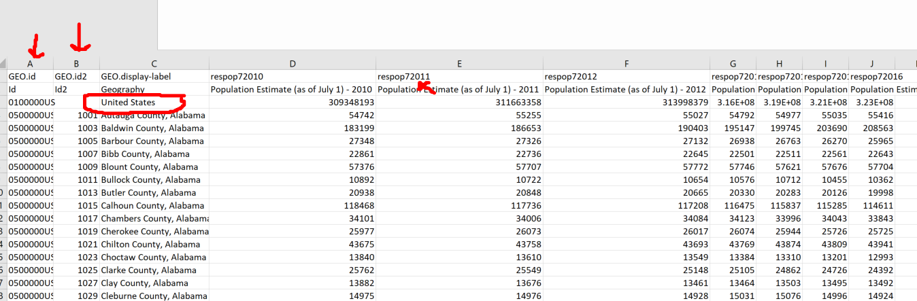

Your table will now look like this:

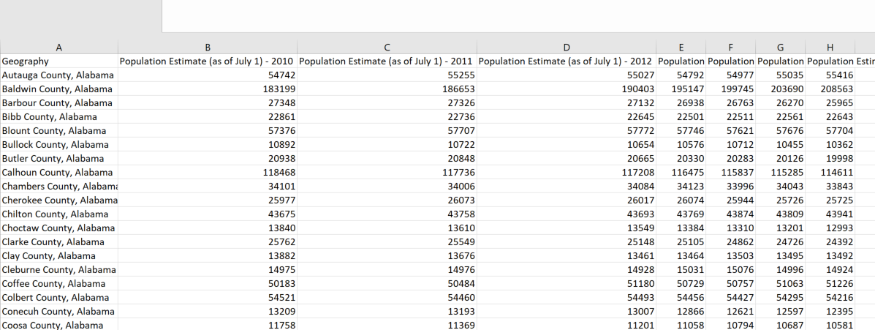

Another best practice is to format your data as a table as soon as it is convenient. Doing so is easy, it makes it more readable, and it gives the data some analysis features right off the bat.

*Click inside your data*

*On the Ribbon, in the Styles section, click on Format as Table*

*Pick a look that you like.*

*It will confirm your table range, and keep the My Table Has Headers checked.*

You will notice that it gives arrows next to the headers. Click on the arrows and you will see options for sorting and filtering your data. This all comes with being formatted as a table! This can be very useful in finding specific information. For example, let’s say you want to find population data for Cook County.

*Click on the arrow next to Geography*

*Under Text Filters, start type “Cook” and hit OK*

But wait…There are several counties with Cook in the name, and you just wanted the one for Cook County, Illinois. It would be better if the state were in its own column, separate from the county. That way you could filter the state to Illinois and the County to Cook. Let’s do a very common transformation with Census data. Let’s break up a cell into multiple cells.

*Clear the filter by clicking on the arrow next to Geography again and choosing Clear Filter.*

*Insert a row next to Geography (select Row B, right click and hit insert)*

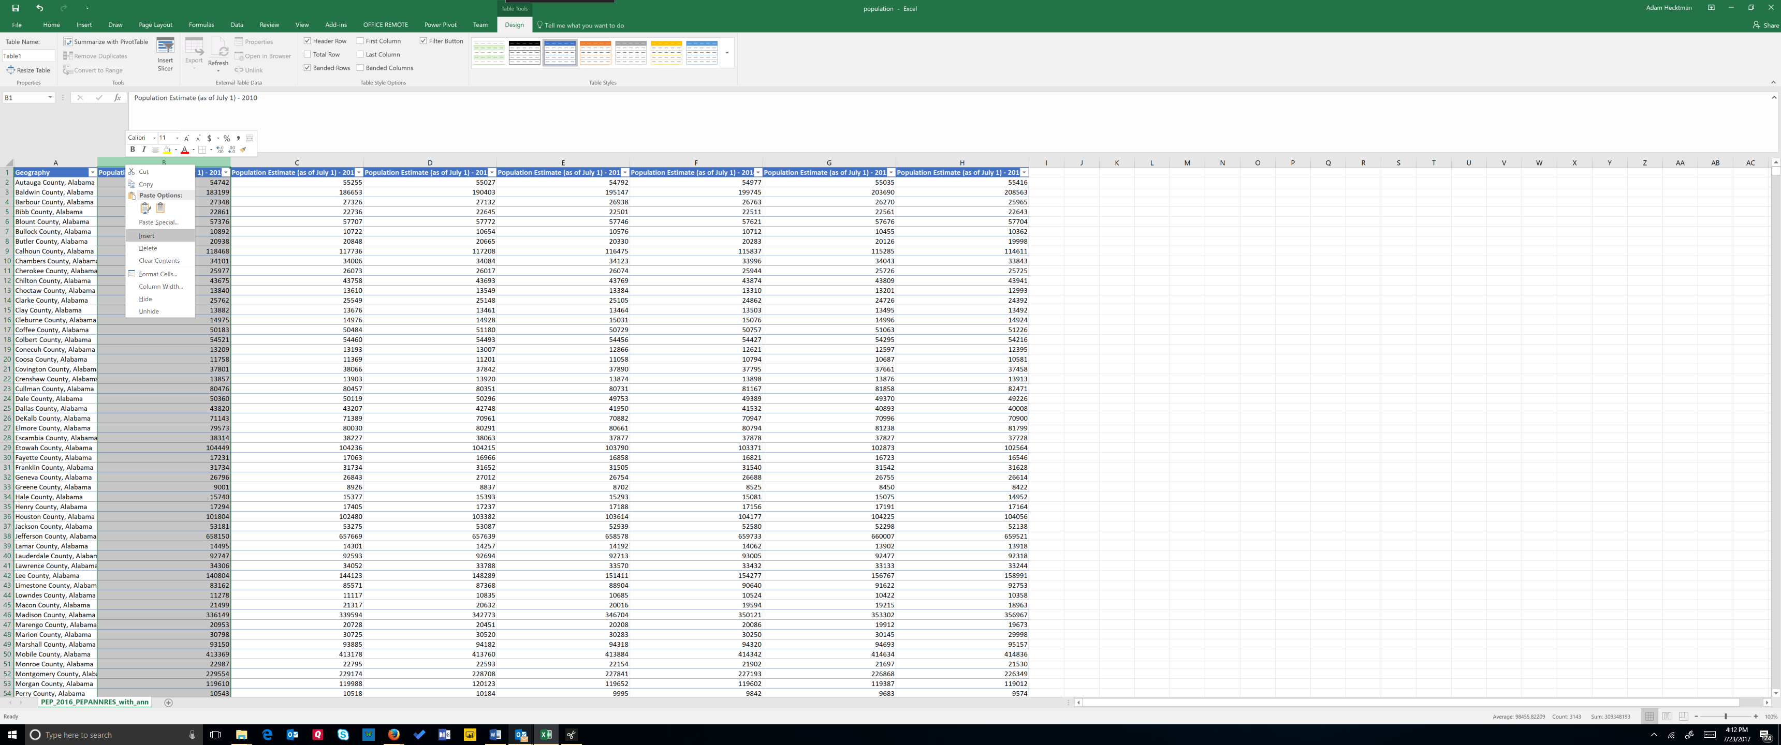

*Select the Geography column*

*On the Ribbon, choose the Data Tab*

*Click on Text to Column and note the preview, this is very useful*

You have some options for how you want to split up your column. You can use a delimeter, meaning that Excel should split up the column based on a character (a comma in this case). Or you can use a fixed width, which you sometimes need for data coming off of legacy systems like mainframes. In this case, we are delimited by the comma that separates the county from the state.

*Choose delimited and click next*

*Check the Comma as your delimiter (you can uncheck tab if you like) and click next*

*Look at the preview and verify it will look the way you want*

*Click Finish and accept the warning if it comes up*

You now have two columns, one for the county name and one for the state name.

*Rename the new column State*

Now you can do things like analyze population data changes for a single state. For example, let’s say we just want to see the data for the state of Hawaii.

*Click on the drop down on the column header*

*Under Text Filter, start typing Haw and you will see that only Hawaii is selected*

*Now you are seeing the population data corresponding to the four counties in Hawaii*

*To go back to the full table, simply click on the drop down again and click on clear filter.*

You now have a fully functioning table. Yet another best practice is to name your table. This will make it obvious which data you are referring to when you do more advanced things like working with formulae and maps. To name this table, simply click on the Design tab on the ribbon, and change the Table Name (in the Properties section of the ribbon) from Table1 to something more meaningful like PopulationCounty.

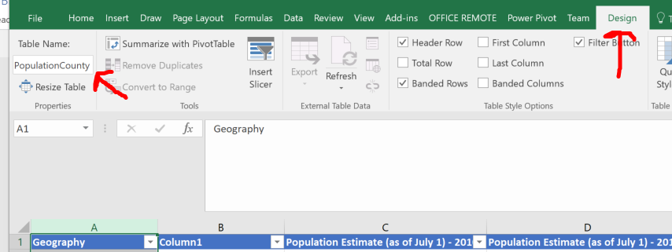

# Quick Analysis

There are some very simple ways to create quick and effective analyses in Excel. Later we will talk about more advanced analysis, but this section will focus on easy ways to derive insights from Census data.

With a table like this, with year over year data, it is useful to see trends. You can certainly quickly create a line chart that shows the trend for each state, but with so many counties, it would be difficult to see the trend for any particular county, as it would get lost in the chart. This is where Sparklines come in handy.

Sparklines are like little charts that live inside a single cells that can be used to visually represent and show a trend in your data. Sparklines can draw attention to important items, in this case population changes. We can also use them to highlight the maximum and minimum values in the row.

Create another column header in the column to the right of the population estimate for 2016 Name it “Trend”. Notice that Excel automatically makes this part of the table for you, complete with formatting.

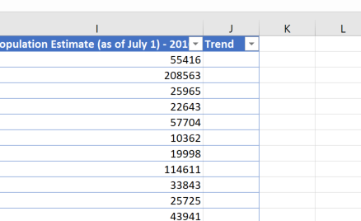

Now, we will use this cell to create a Sparkline to see the population trend for that county.

*Click in the first cell under Trend*

*On the ribbon, click on the Insert tab. In the Sparklines section, you will see some options.*

*Start with the Line Sparkline. For Data Range, select the row of population estimates (C2:K2)*

*That sparkline shows the trend, year over year, of the population for that county!*

*Now, you can copy the sparkline for every county.*

*Using a shortcut, you can select every cell in that column in that table by holding ctl+shift+end*

*Now, from the home tab on the ribbon, in the editing section, choose fill/down.*

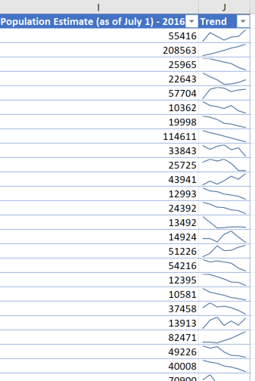

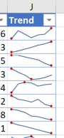Now you can quickly see the trends for each county! That is a lot of great insight in a single cell. But it would be also very useful if you could see where the highs and lows are.

*Click on the Sparkline Tools Design tab on the ribbon.*

*Note in the Show section that you have a variety of things you can show in each cell.*

*Select the high point and low point*

*You can even change the colors of what is the high point and what is the low point.*

*Experiment with the style options*

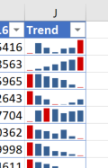Line charts are not your only option. You can also use a column chart or a win/loss chart.

You can experiment with these, but the trend is easiest viewed with the line chart in this scenario.

There is a quick menu of tools called the Quick Analysis Tools that provides a trove of insights that you can add to your Census data. You can instantly create different types of charts, including line and column charts, or sparklines. You can also apply a table style, create PivotTables, quickly insert totals, and apply conditional formatting. Here, we will add icons, another way to do quick visual analysis right from within the cell. To experiment with these, select the cells in the first row of data (the population estimates for Autauga County, Alabama)

*Hit Ctl+Q, which is the keyboard the shortcut for Quick Analysis Tools*

*In the mini toolbar, you can see you have a variety of options for doing analysis of your data.*

*Hover over some of these to get a preview of what they do.*

*Then click on Icon Set*

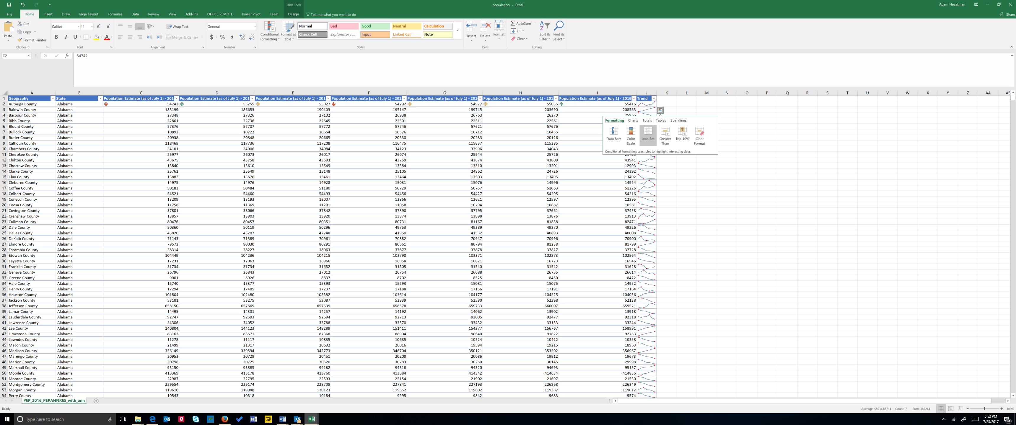

The icon set puts icons directly in the cell based on conditions. In this example, it tells you if the population went significantly up, down or stayed relatively flat.

*Next, select the data on one of the other rows.*

*Hit Ctl+Q again to bring up the quick analysis tool.*

*This time choose Data Bar. This shades the cell based on the data in that cell.*

*Experiment with some of the other quick analysis options.*

These tools are actually examples of conditional formatting. As you saw, conditional formatting rules to help you do things the built-in formatting rules can’t do. To see what they look like, click on the Conditional Formatting in the Style Section of the Home tab. Here you can not only see the wide variety of icons, data bars, and color schemes you can use, at the bottom (Manage Rules), you can manage how these visualizations are applied.

# Mapping Census Data in Excel

Let’s say we want to plot on a map the median household income for each state, along with the number of people in each state that have completed high school education.

We can leverage the Community Facts in the American Fact Finder again to find the data that we need. Let’s start with a very simple table, a comparison of median household income per state found in the Income section.

*Click on the Community Facts from the top menu on American Fact Finder*

*Click on Income on the left*

*Choose Compare States for Median Household Income*

*From the table page, choose Download*

*Select Use Data*

*Click Download*

*Unzip to your computer and open the CSV file*

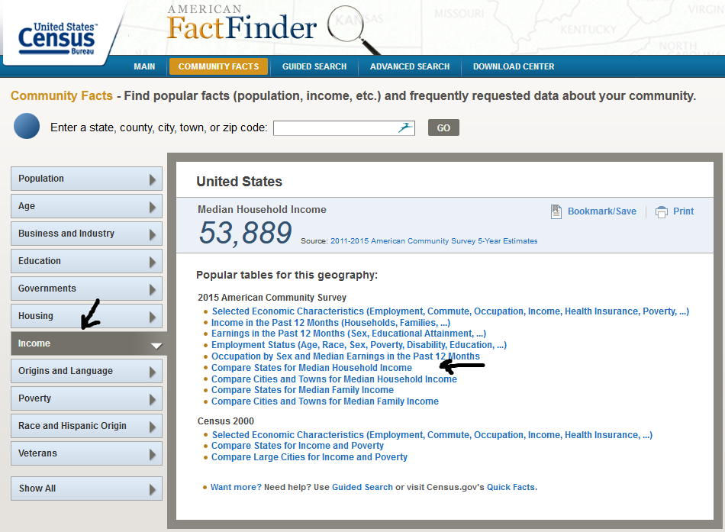

Again, apply your best practice of saving this CSV file as an Excel Workbook file right away.

*File/Save As/Excel Workbook with a meaningful name*

Next, we can delete columns we *won’t* be using.

*Delete the columns containing GEO.id, GEO.id2, GCT_STUB.target-geo-id, GCT_STUB.target-geo-id2) , and the margin of error column, HC02.*

*Also delete that first data row for the overall United States (row 2).*

Let’s give our headers useful names. Name the header of Column A “State” and Column B, “Median Household Income”.

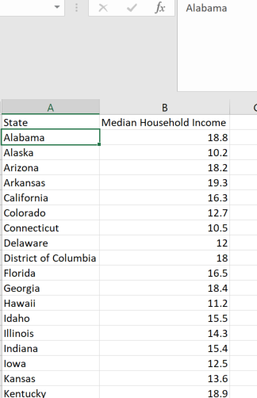

Next, let’s turn this into a table to access all the table features.

*Click on Format As Table*

*Pick your favorite style, and make sure the “My Table Has Headers” box is checked.*

Give your table a meaningful name by changing the “Table1” in the Table Name Box (in the Table Tools Design tab) to something meaningful:

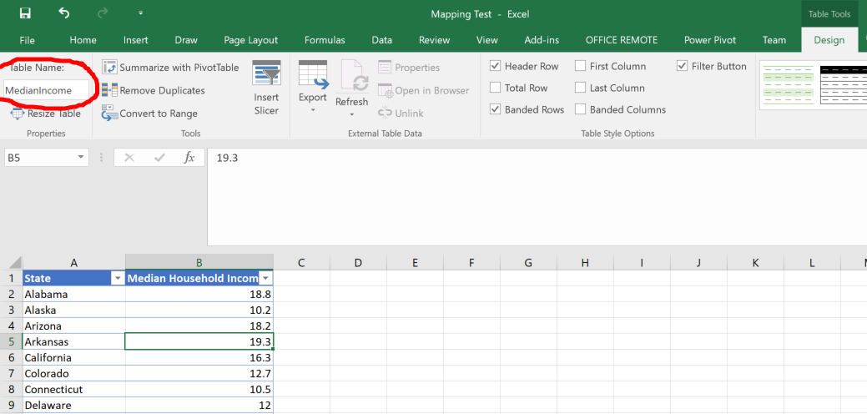

Let’s find the high school education data and put it on another tab in this workbook

*Click on Community Facts*

*Select Education*

*Click on Compare States for People Who have Completed High School*

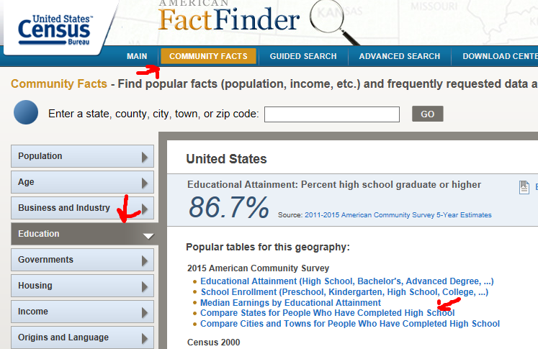

Again, if your data transformations are simple, you can do them before you even download the data.

*With the table up, click on the Modify Table button.*

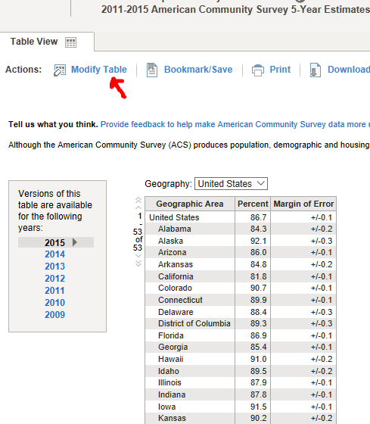

Again, you have the ability to modify the table by deleting elements, moving elements, even transposing rows and columns.

*We are simply going to uncheck the Margin of Error column.*

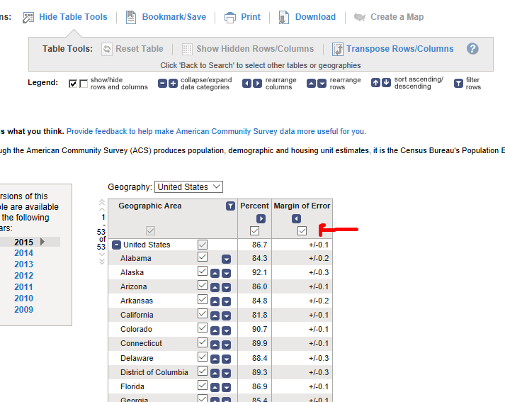

*Download as before, and extract the file into Excel as a CSV file.*

*Remember to save this as an Excel Workbook right away.*

*Delete columns A through F, as before.*

*Delete the row showing the total for the United States*

*Names your headers State (or StateEducation), and Percent Completed HS.*

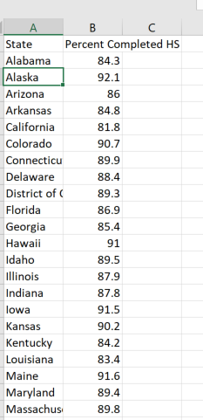

*Click on Format as Table from the Styles section of the Home tab on the ribbon.*

*Ensure that “My table has headers” is checked, and hit ok.*

*Give this table a meaningful name by changing Table Name in the Table Tools Design tab of the ribbon from Table1 to something you like.*

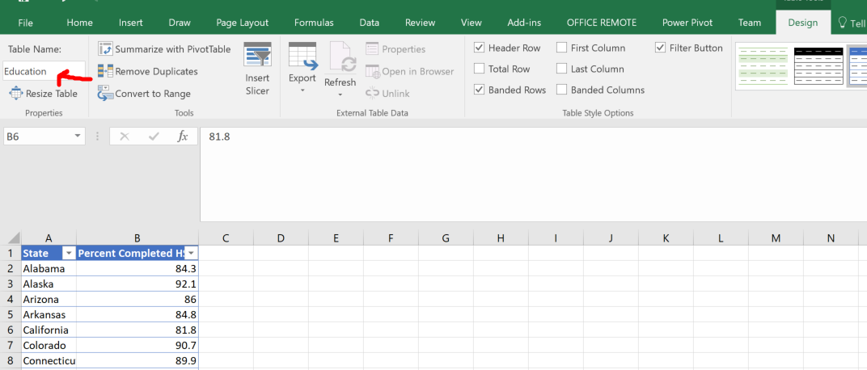

To minimize jumping in and out of multiple workbooks, move this spreadsheet into the workbook with the Income data.

*Right click on the tab at the bottom with the name of your current spreadsheet.*

*I’ve named mine “Education”*

*Choose Move or Copy…*

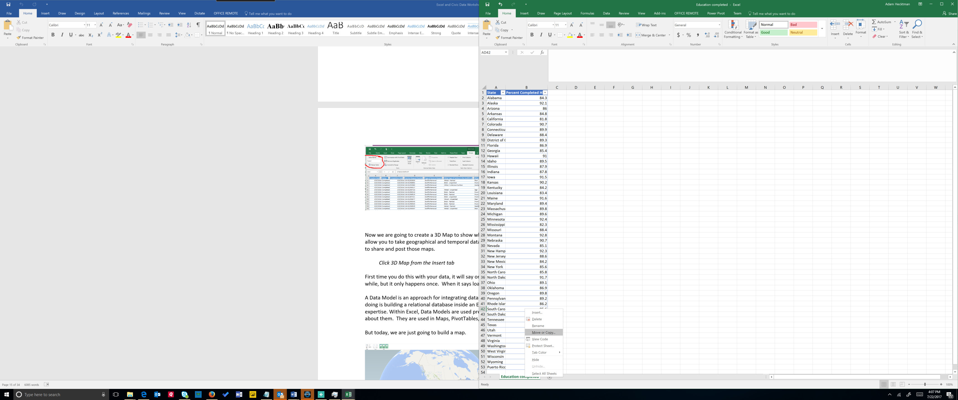

You will see that you can change the workbook you can copy or move this to.

*Click on the drop down and select the first spreadsheet you had been working on.*

*I named mine “Income”.*

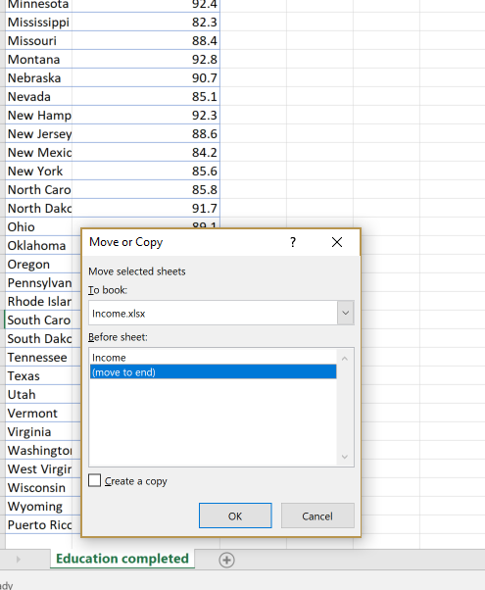

Now you will have one workbook with two tables. You can verify that the tables have been named the way you want by choosing the tab with the data, clicking in the table, choosing the Design tab on the ribbon and looking at the table name:

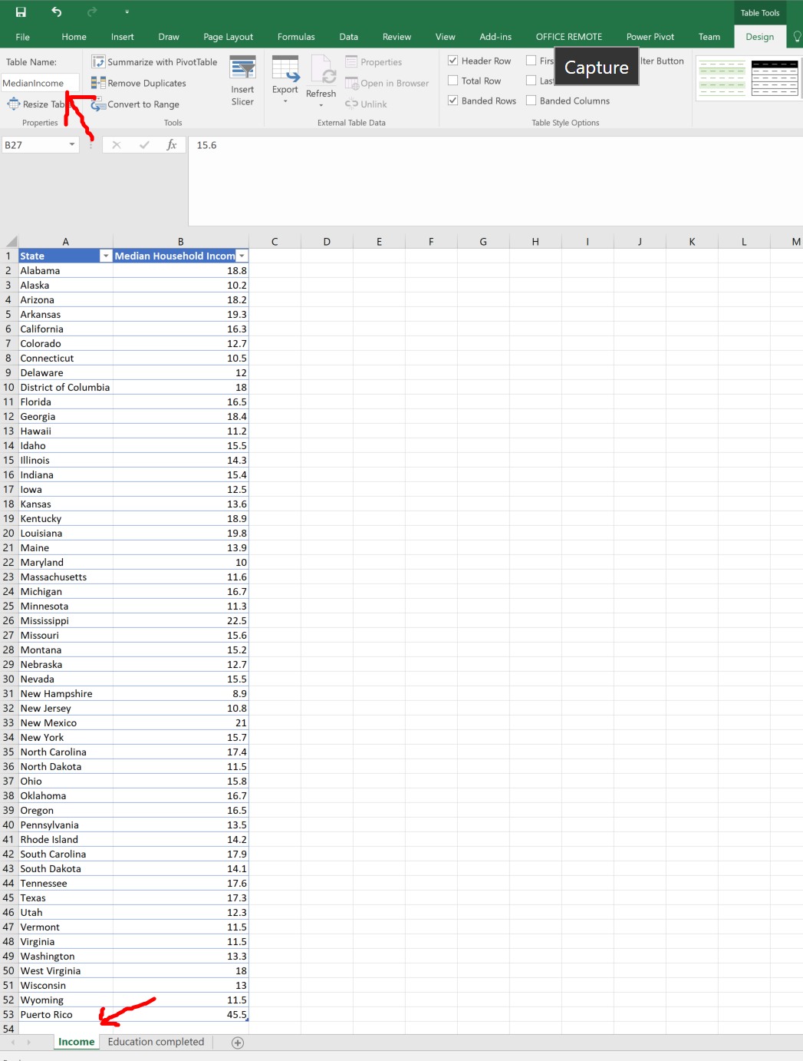

Now we are going to create a 3D Map to visualize both the income and the education levels across the states. 3D Maps allow you to take geographical (and time) data and turn them into maps, and even create videos to share and post those maps.

*Click 3D Map from the Insert tab*

First time you do this with your data, it will say on the bottom "loading model" and this may take a while for very large data sets, but it only happens once. When it says loading model, it is referring to a data model.

A Data Model is an approach for integrating data from multiple tables. Effectively, what you are doing is building a relational database inside an Excel workbook, without having to have database expertise. Within Excel, Data Models are used pretty much without you having to know anything about them. They are used in Maps, PivotTables, Pivot Charts, and Power View reports, etc. But today, we are just going to build a map.

You will have a screen that looks like this:

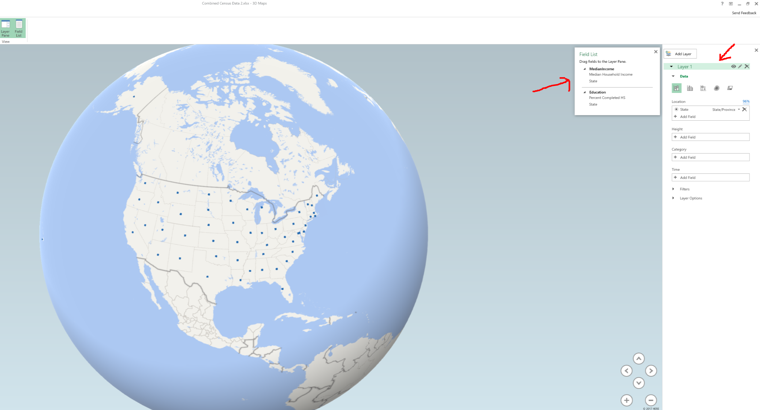

Let's talk about some terminology. On the upper right, you will see the fields in your tables. You should now be able to appreciate the fact that you named your tables something useful!

**Layers**

To the right of that are the options for the *layer*. You create layers that show specific data on your map (like the number of graffiti requests). You can combine layers on top of layers, and then build *scenes* from those layers. When you have a time dimension (such as something that happens every day, week, month, etc), map scenes are like scenes in a movie, with transition effects and all. Then, you can combine scenes into a tour. Here we only have spatial data.

The first decision you need to make is the type of map we want to create. We can choose a column chart, a stacked column chart, a bubble chart, a heat map, a shaded region, even add a custom map type. Let’s start with a stacked column chart so that we can have a column whose height represents the median income for the state.

The second decision you need to make is which fields in your table you want to use to denote location. Excel Maps make it easy to do, but it is an important question to consider. It relates to the question of what you want your analysis to answer. In our case, want to review data at the state level. But Census is rich with data for cities, counties, metropolitan statistical areas, census tracts, etc. Some datasets may even contain latitude/longitude coordinates. Excel’s 3D maps can handle all of them.

In this case, we are going to use the state data for median income. Excel has already predicted that you want to use State, and that the field named State refers to a US state. Go ahead and delete that by hitting the x next to it so you can see how to do this manually.

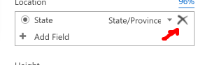

You could add the geography field this way:

*In the Location box of the Layer options, choose +Add Field, and add State from the Median Income table*

Now, let’s add data to represent the height of that column.

*In the Location box of the Layer options, choose +Add Field, and add State from the Median Income table*

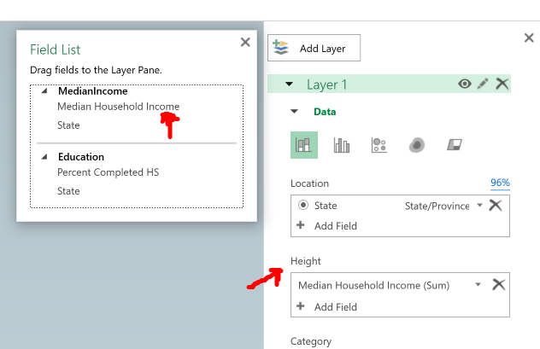

Just as with tables, it is always a best practice to name your layers. Whatever you name your layer will also show up in a legend that gets created automatically for you. In the upper part of the box, click on the pencil to the right of the label Layer 1 and give it a meaningful name. We can call it Median Income:

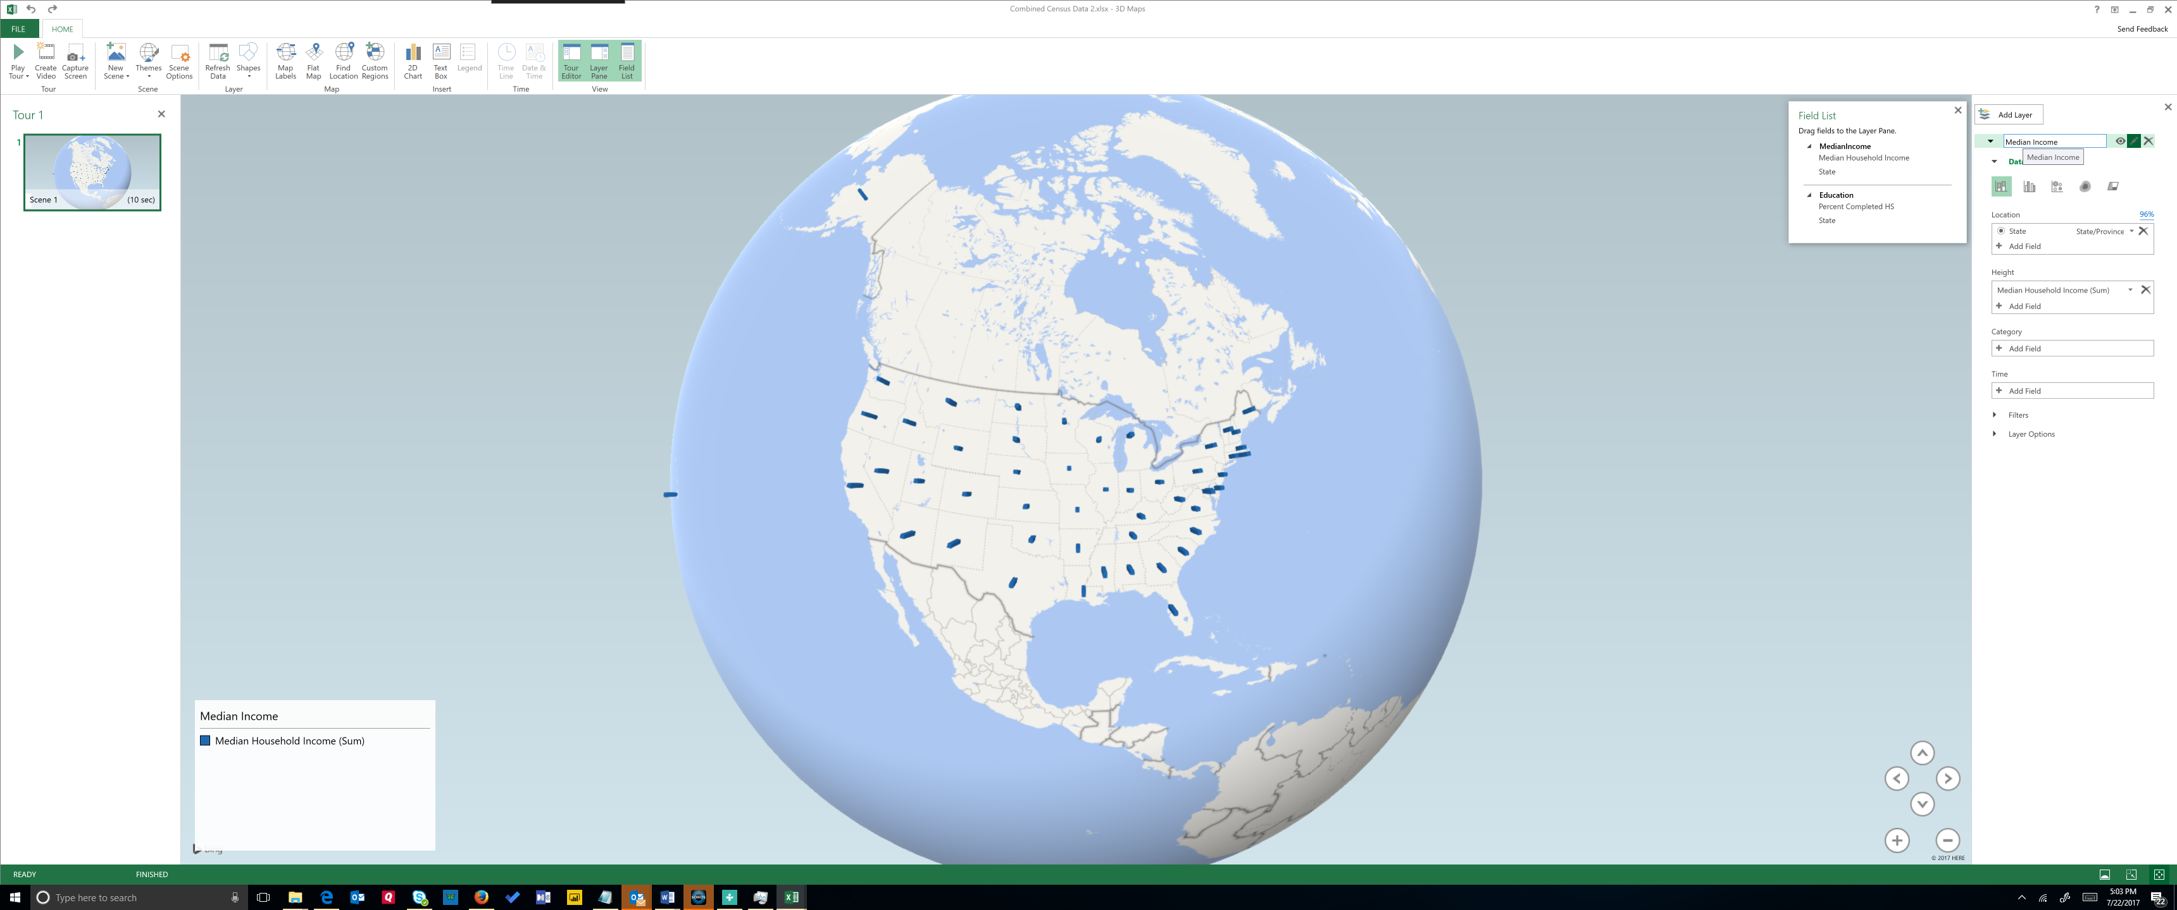

To make it obvious which state is which, use Map Labels:

*Click on Map Labels from the ribbon*

Take a few minutes to explore this map.

*Zoom in using the mouse wheel or using the + and - buttons*

*Tilt up and down using the arrows*

*Generally explore the map by moving around*

When you hover over one of the data points, you see text from that data point in the form of what is called a custom card. You can create custom cards that show all kinds of data. You can also add your own annotations. Let’s annotate Mississippi and point out that it has the highest median household income.

*Right click on the column in Mississippi and choose Add annotation*

*In Title, type Highest Median Income*

*In description, note that you can type anything you want, add a field, or insert an image.*

*Here we will add a field, and select both data points.*

Feel free to add other annotation. Let’s add a second layer with a different chart type, this one a shaded region chart.

*Click on the Add Layer button to get your next layer. Note that the first layer will still be visible (unless you click on the little eye icon next to the layer name).*

*In the Location box of the Layer options, choose +Add Field, and add State from the Education table*

*Change the chart type to the Shaded Region chart*

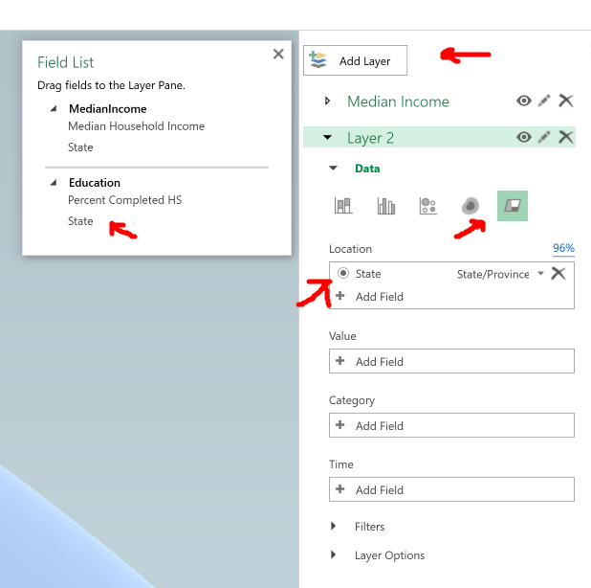

Now, let’s add data to represent the shading within the region.

*In the Value box of the Layer options, drag Percent Completed HS into the value field*

You now have a visualization that shows you which states have a relatively higher percentage of people completing high school. But you can make it even more clear.

*Click on Layer Options and change the color scale to 20%*

*Rename the layer form “Layer 2” to something more relevant like “Percent Completed High School”*

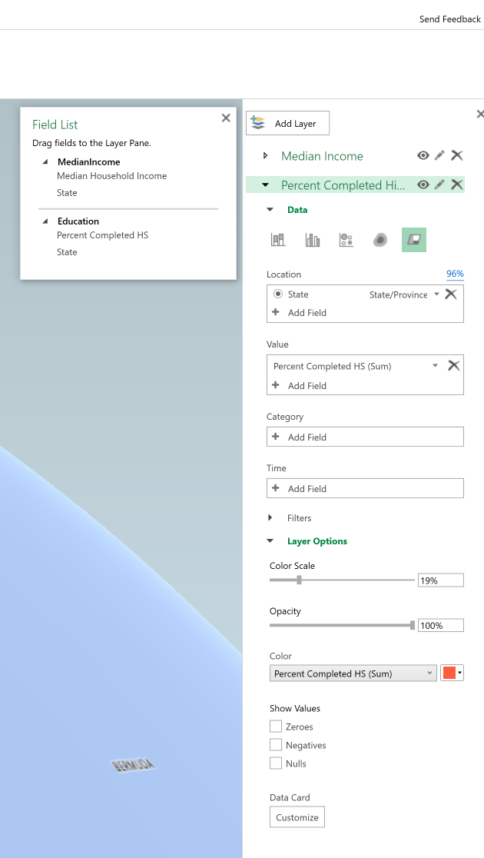

On the lower left, you will see the legends clearly.

*Move them it so that it is in the upper left (in the sky).*

**Scenes**

Scenes allow you to visualize your map like a movie. You can even add a soundtrack! In this case, we are going to build two scenes: one that shows just the shaded region map that denotes the percent completed high school, and then a second scene that adds the median income. We will combine the scenes into what is called a “tour”, and each scene will have different visual effects to allow you to see it better.

*In the Layer Pane, click on the eye icon to hide the Median Income layer.*

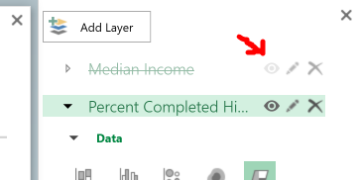

*On the left side of the screen, you will see your tour pane with one scene.*

*Click on Scene Options in the ribbon*

*Give the scene the name Percent Completed High School*

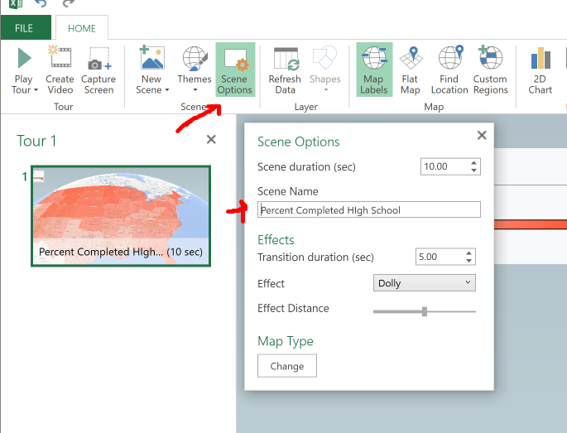

*Change the transition duration to 5 seconds. This is how much time the scene spends on this particular view of your map.*

*Assign an effect (I suggest Dolly).*

*You can test your work by clicking on the Play Tour button on the ribbon towards the left side.*

Now let’s create our second scene. We will add to this shaded region the column chart of median income.

*Choose New Scene from the ribbon (or right click on the first scene)*

*Unhide the Median Income Layer by clicking on the eye icon*

*Click on Scene Options and name this scene “Add Income Data”*

*Change the transition duration to 5 seconds*

*Assign a different effect (I suggest Circle)*

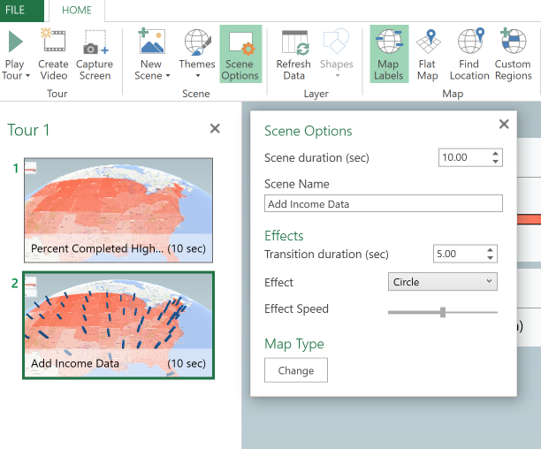

*Play the tour*

You can see that when the income data points come in, the movement of the map changes.

Custom Maps and Local Census Data

This section brings together many of the skills you have learned so far, and adds two more. Census data is not just about national statistics. There is an abundance of data at the state, county, city and town level. There is also plenty of census tract and census block data. But how, on the map, would you see the geography that corresponds to that census tract? This is where Custom Regions come in.

Let’s say we want to map both the 10 year population change and the 10 year housing change for all of the census tracts in the state of Illinois. We need two things. First, we need the data. Second, we need a way to tell Excel where those census tracts are on a map. Census has both of these.

First, let’s get the data and bring it into Excel. We are looking for 2000 to 2010 census tract population changes. You can use the search options in American Fact Finder. But for simplicity, the spreadsheet can be loaded here:

[http://www2.census.gov/programs-surveys/decennial/tables/time-series/tract-change-00-10/censustract-00-10.xlsx](https://na01.safelinks.protection.outlook.com/?url=http%3A%2F%2Fwww2.census.gov%2Fprograms-surveys%2Fdecennial%2Ftables%2Ftime-series%2Ftract-change-00-10%2Fcensustract-00-10.xlsx&data=02%7C01%7Cadamh%40microsoft.com%7C6ce5ef58998140a1f1b708d4d2fab5de%7C72f988bf86f141af91ab2d7cd011db47%7C1%7C1%7C636365421615769556&sdata=mSMbARiVTU1UyowLSB2qJkyttLfv4FwhSlsGS1YUAXg%3D&reserved=0)

*Open this spreadsheet and we will simplify it.*

*Delete all columns but TRACT10, NPCHG, and NHCHG.*

*These are the census tract number, the population change over 10 years, and the housing change over 10 years.*

*Format it as a table in whatever style you like*

*Save it as an Excel Workbook somewhere on your computer*

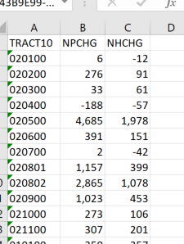

Now, we need something that tells us what all those tracts actually look like on a map of the state of Illinois. Census maintains files called KML or SHP files that can be used for this purpose.

*From Census.gov, choose Geography from the menu bar at the top of the page*

*Choose Maps & Data*

*Choose TIGER products*

*Click on KML-Cartographic Boundary Files.*

*These are the files that you can use not only in Excel, but a variety of mapping tools.*

*Click on Census Tract under State-based Files.*

*Select Illinois*

This will give you a zip file that you should extract to your computer. The one we are most interested in is the KML file. We will import that into Excel.

Now, to bring it all together!

*In the spreadsheet you just created, choose 3D Map from the Insert tab and add a map.*

*For location, choose TRACT10. But you need to tell Excel what a tract looks like, right?*

*Set the location type to be a custom region and you will be prompted to import the region.*

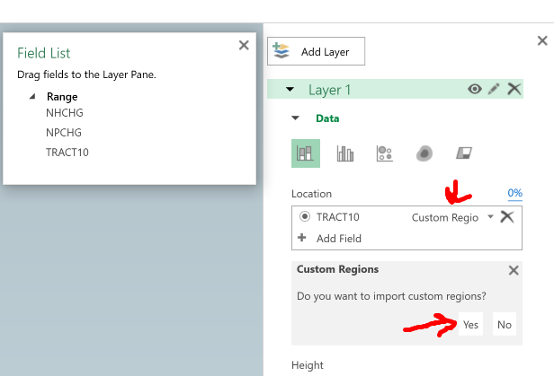

*Click Yes and point it to the KML file that you downloaded and unzipped.*

*Give it a friendly name, if you wish*

*Now, the region name in this KML file is TRACTTCE, so select that*

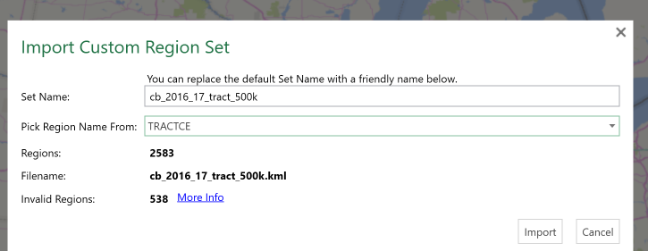

*Now, let’s give it a more professional look.*

*In the map type, choose the shaded region type.*

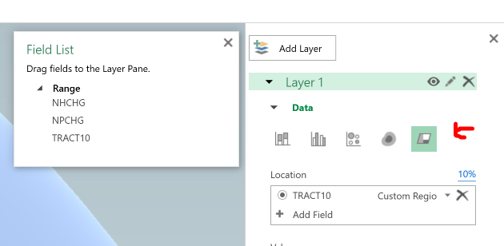

You are starting to see the census tracts come alive.

*For the final flare, drag NHCHG (number household change) and NPCHG (number population change) to the value field.*

*Name the Layer something useful*

*You now have a custom map with data by census tract*

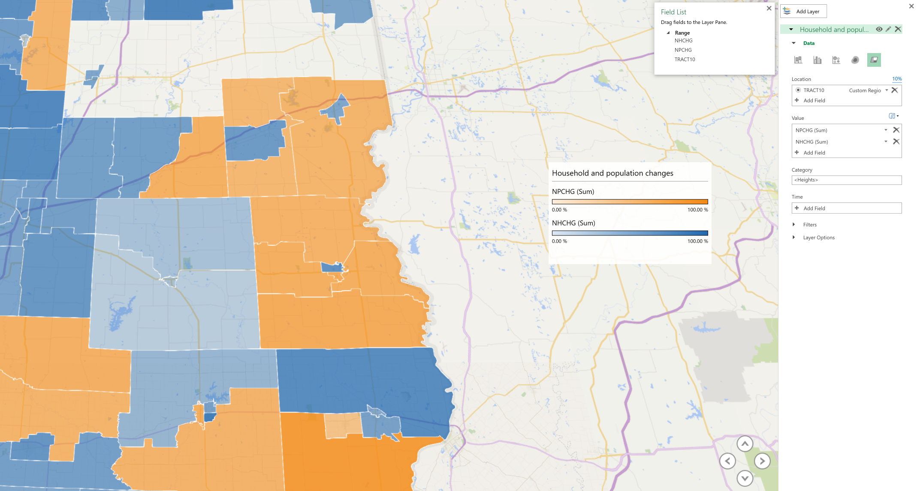

Advanced Search and Hierarchical Charts

In this section, we will explore two topics. First, we will look at how to use the Advanced Search feature of the Census American Fact Finder. Then we will modify and download a dataset, and use that to create a hierarchical chart (a chart that highlights data in multiple categories).

Let’s say you want to understand the income gap between males and females with varying levels of education. You can see that we are looking at three separate variables. Income, male and female, and education level. Let’s search the American Fact Finder using those variables to find exactly what we are looking for.

*Go back to American Fact Finder (*[*http://factfinder.census.gov*](http://factfinder.census.gov)*).*

*Click on Advanced Search on the menu.*

*On the left, click on Topics under the search options.*

*Here you will choose the three topics mapping to the three variables.*

*Start with male vs. female. These are people, so click on People.*

*Click on Age & Sex.*

*Click on Sex.*

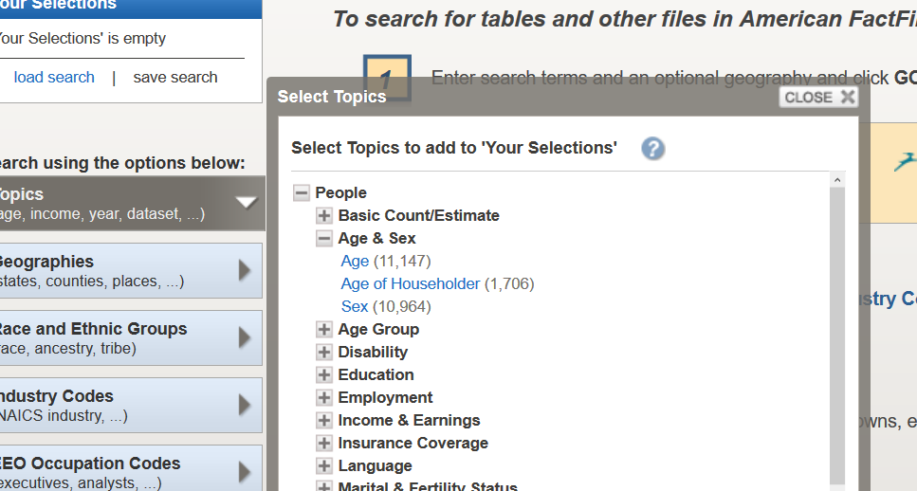

*Notice that when you do that, it has added Sex to your search criteria in the box on the left marked “Your Selections”.*

*Now we want to find Income. Choose Income and Earnings.*

*Choose Income/Earnings (Individuals). It is added to your search criteria.*

*Last, we want this data by levels of education. Click Education*

*Choose Educational Attainment*

For this example we will look at national level data. You will not need to select a geography in AFF since the US is the default geographic level. However, if you are interested in conducting the same analysis for different geographies, you just need to use the Geography search option right below topics to select it.

*Close the search box*

*The second report gives you median earnings by sex by educational attainment. Open this.*

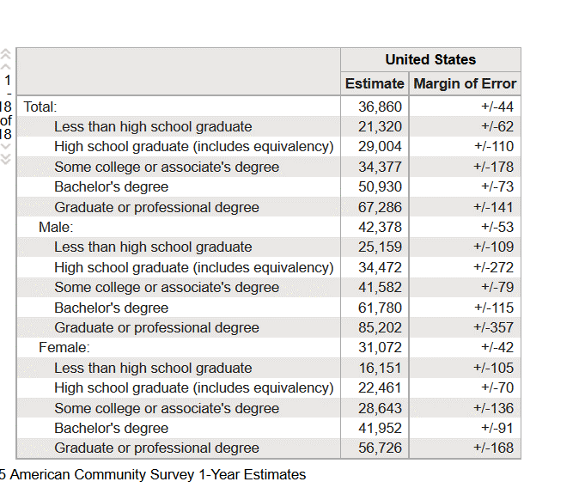

Quite often, you will want to analyze or visualize census data across several different categories. You may be already familiar with using Excel charts to map single categories. But there are several charts in Excel that are particularly good for hierarchal data. An example of such data may be the average earnings (the data) for people with varying levels of education (one category), broken down by gender (a second category). With a bit of cleaning, we can do that with this table.

*First, click Modify Table.*

*Uncheck the Margin of Error column.*

*Uncheck the education levels under Total, as we won’t be using those.*

*We can structure the data further in Excel.*

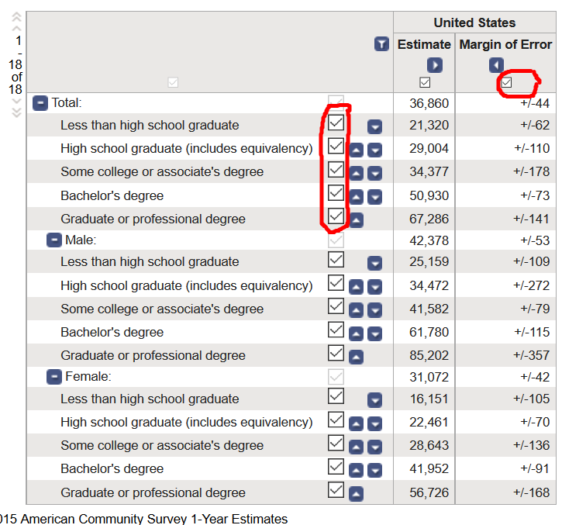

The view should look like this:

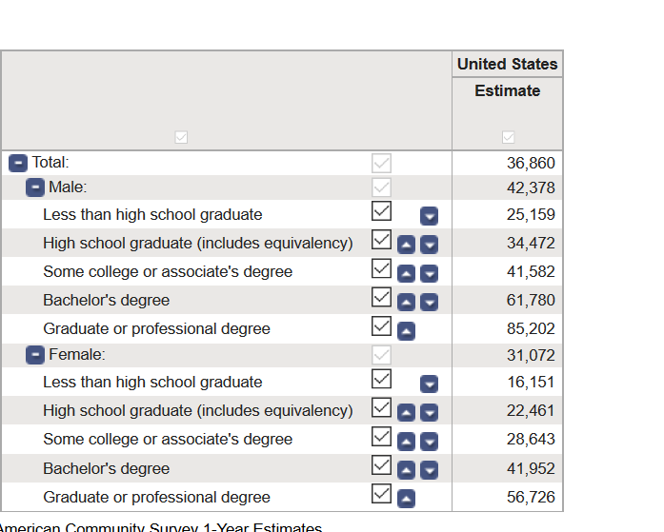

Now, we can take this opportunity to learn another way to download data from Census.

*Click on Download, and instead of choosing Use (which downloads in CSV), choose View (which downloads in PDF or Excel).*

*Select Excel as the presentation format.*

*Hit Download.*

*Open the file.*

Your data is now exactly as you structured it, with a few extra columns and rows. There is some verbiage which (once you read it), you can delete.

*Delete the first 8 rows above your table, and then all the rows of text below it (should start at row 16).*

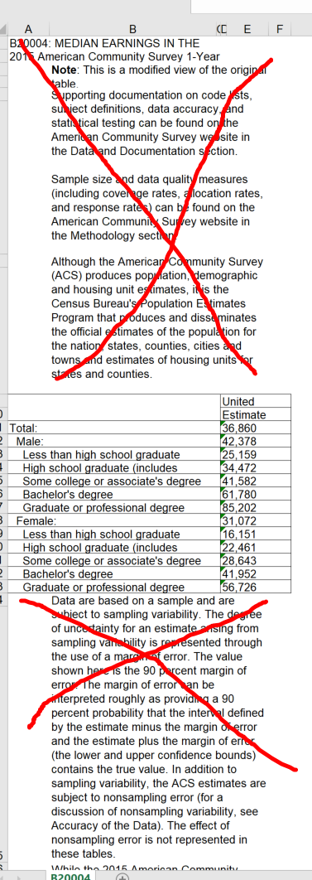

Now, recall our best practice of saving these files as an Excel Workbook right away? That applies even here where it is an Excel file already. The reason is that this is actually an Excel file in compatibility mode. This means it is meant to be used by someone with Excel 97 – 2003. There are many…loads…of features that are available in more recent versions that you will want to take advantage of. Saving this is a two-step process:

*File/Save As/type is Excel Workbook*

*Close and re-open the file so that you are no longer in compatibility mode.*

Now let’s simplify this table a bit.

Your table will look like this.

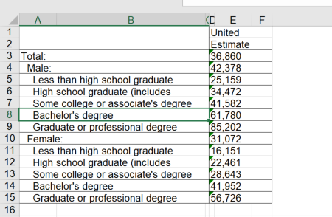

At first glance, it looks fine, but actually there are some extra columns that are a little hidden. Start by deleting the first row.

*Delete the first row.*

*Next, delete the row that says total*

*Delete Column C*

*Delete Column B*

*At this point, you should have this:*

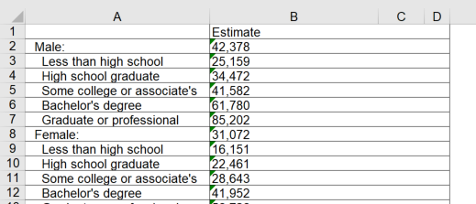

Now, again, a hierarchical chart has several columns of criteria. We want to separate Male and Female into their own columns.

*Add a column to the right of A*

*Move the labels “Male” and “Female” into those columns, and delete the estimates for each.*

*Label the Column “Sex”*

*We are very close. You should have:*

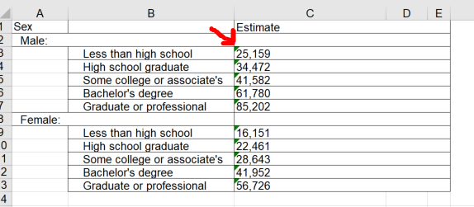

But what is with those green little triangles in the corner of the cells in column C? That is Excel telling you it has found something that could save you hours of frustration later on. Select those cells (or even just one of those cells) and you will see a little warning icon in the upper left of the selection.

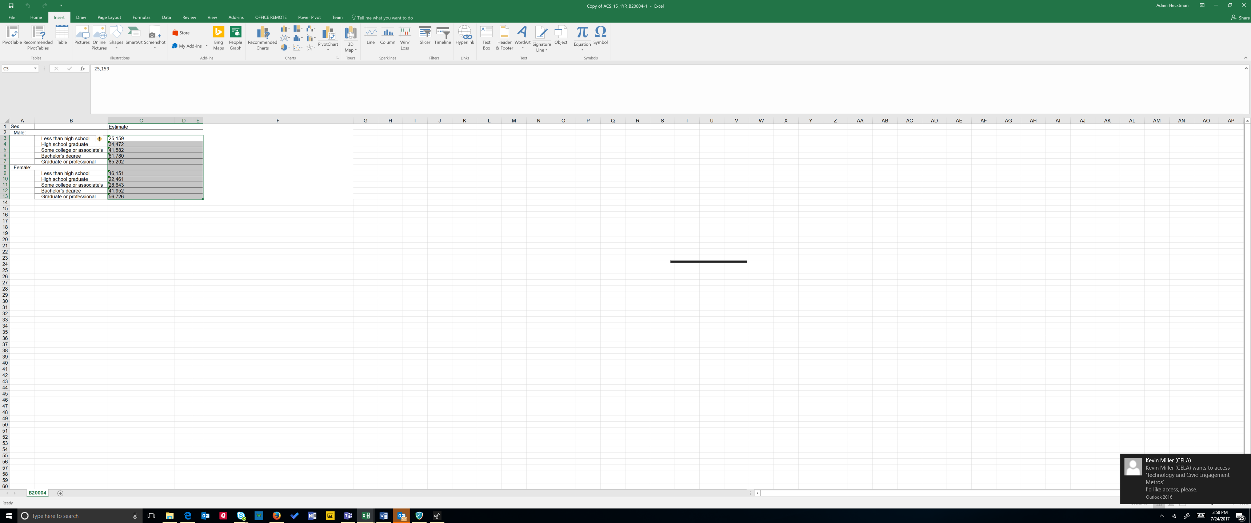

Click on it and you will see that it is saying that these could be numbers or these could be text!

*Choose convert to numbers.*

*Now we are ready to make this look nice.*

*Select your table and choose Format as Table*

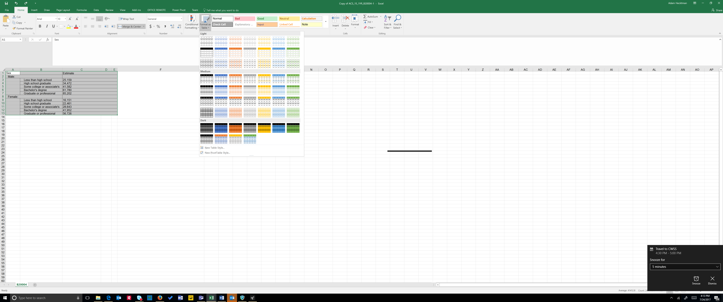

*Get rid of those two extraneous row*

*Give Column B the title “Education Level”*

*Now you have a hierarchical table.*

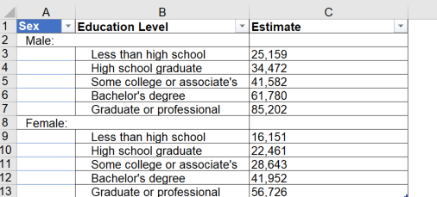

There are charts in Excel 2016 that are particularly well suited to give you visual insights into data like this. A treemap chart provides a hierarchical view of your data and makes it easy to spot patterns. The tree branches are represented by rectangles and each sub-branch is shown as a smaller rectangle. The treemap chart displays categories by color and can easily show lots of data which would be difficult with other chart types.

*Select your table*

*Click on Recommended Charts on the Insert tab of the ribbon*

*Scroll down and look at the previews*

*Choose the Treemap*

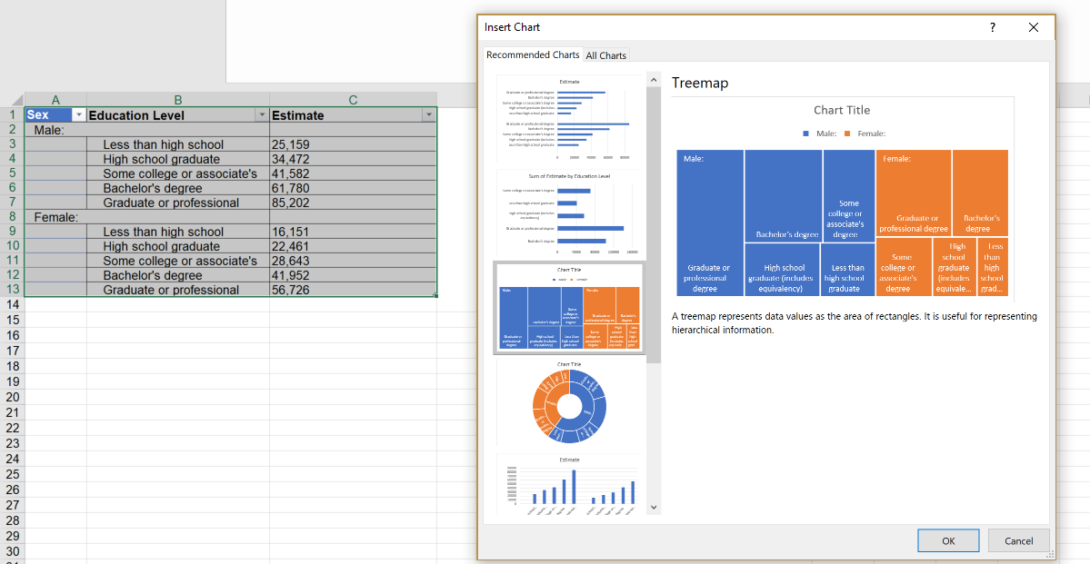

When you expand the chart, you will see many of the same options you see in other charts. For example, you can click on Chart Title and give it a meaningful name.

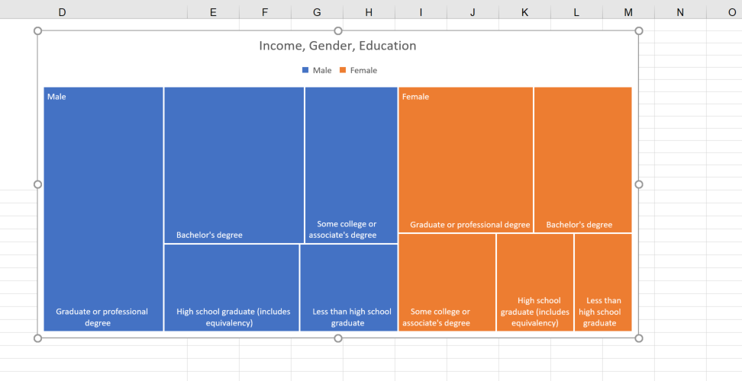

From the ribbon, you can also experiment with styles and layouts by hovering over the options. That way, you do not commit to the look you like until you select it:

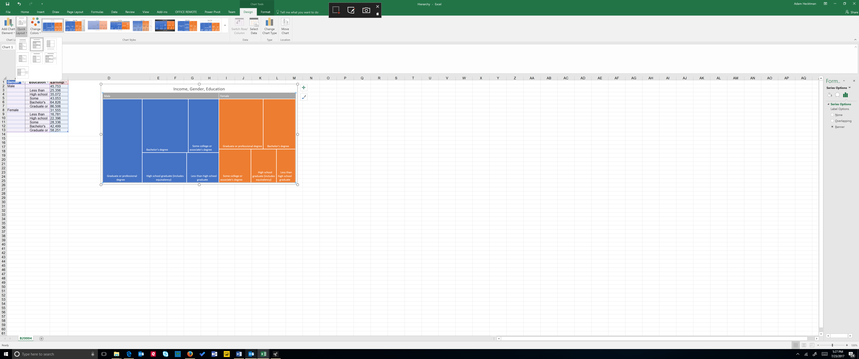

You can also Treemap charts are good for comparing proportions within the hierarchy, however, treemap charts aren't great at showing hierarchical levels between the largest categories and each data point. A sunburst chart is a much better visual chart for showing that. To see how this same chart looks as a sunburst chart:

*Click on the treemap chart*

*From the Design tab on the Ribbon, choose Change Chart Type*

*Select Sunburst*

The sunburst chart is actually quite similar to the donut chart. It is as if you had a donut chart inside a donut chart, each level reflecting a category of your information

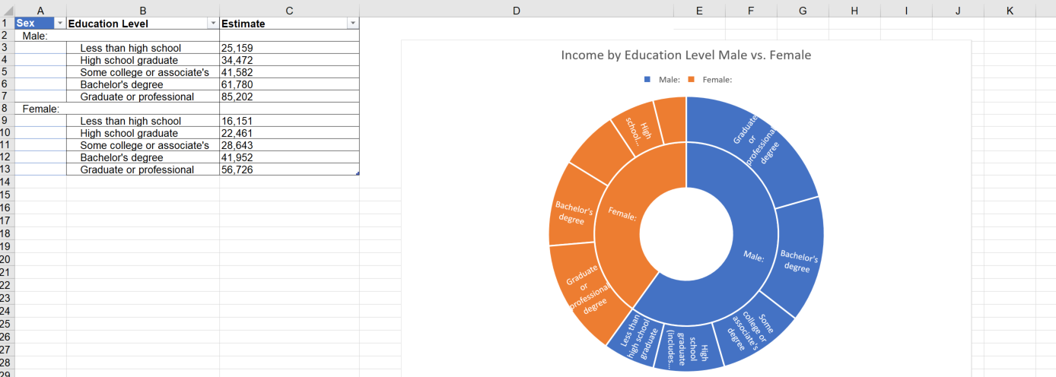

If you want to move around the categories (for example, instead of earnings by education by gender, you want earnings by gender by level of education), a much more flexible and dynamic way of looking at this data is through a pivot table. That is beyond the scope of this particular course, but it opens up new worlds for manipulating your data.

Advanced Data Analysis Tools

The vast majority of time, Excel as-is it provides you with what you will need to access, combine, query, massage, transform, visualize, and otherwise play with your data using the visualizations, formulas, and functions. There are, however, advanced tools for statistical analysis that you can turn on as an add-in. You do not need to download anything, you just need to turn it on. Doing so will give you tools for

* + Regression testing
  + Histograms
  + Anova, correlation, and covariance
  + Exponential smoothing
  + f-tests, z-tests, and t-tests
  + Fourier analysis
  + Moving averages, rank and percentile summaries
  + Sampling and a more sophisticated random number generator than the standard function

**Enabling the Add-in**

Going through all of these statistical functions and methods is beyond the scope of this training, so I will just give you a basic idea of how it can be used with a few examples. We will enable the add on, and do some basic analysis on the Income spreadsheet.

*To enable the Add-in, click File, Options, and choose Add-ins.*

*If you do not see the Analysis Tool Pack already in the list of add-ins, choose Excel-Add-ins from the Manage drop down in the bottom and hit Go*

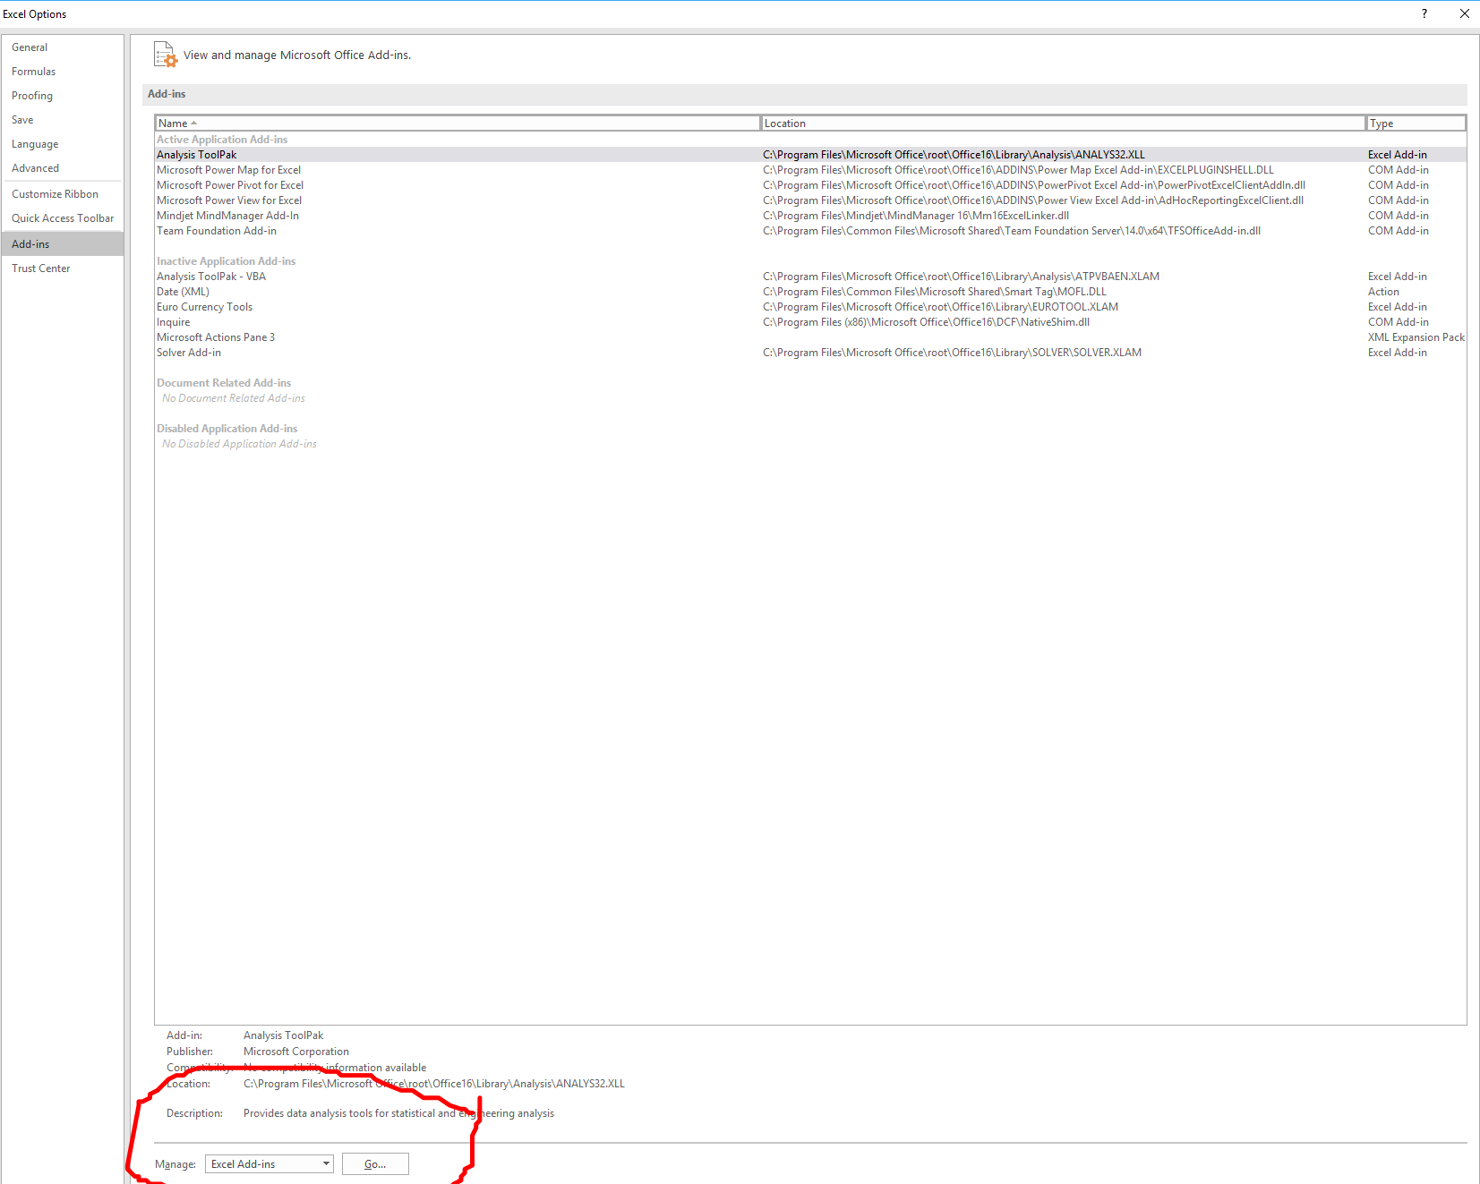

*You will see a list of available add-ins. Check Analysis Tool Pack and click OK.*

*Now, when you click on the Data tab, you will see the Analysis Tool Pack.*

**Descriptive Statistics**

Descriptive statistics describe the main features of a Data set. They are the basic statistics you would generally want to start with, even if you are doing more sophisticated analysis of data. Descriptive statistics provide, for example, information about the central tendency, variability, and overall shape of your data in a few clicks.

*Click in the Income table*

*Choose Data Analysis Tools from the Data tab*

*Choose Descriptive Statistics.*

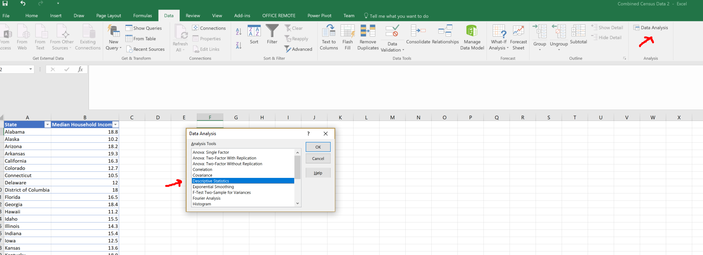

*Give it the input range (which should be the median household income, including the column heading at the top, and Puerto Rico at the bottom).*

*For this example, have it group the data by column*

*Output the data to a New Worksheet Ply name it Descriptive Stats*

*Check Summary Statistics*

*Hit “OK”*

You will now have a new tab called Descriptive stats. Again, these are useful for your first glance at the data to initiate your statistical analysis.

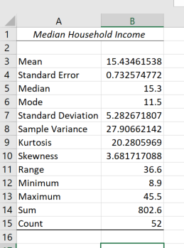

**Histogram**

A histogram is a chart that tells you the number of occurrences of a value or range in a data set. You may recall from school that sometimes letter-grades were distributed in odd boundaries. Chances are good that your teacher used a histogram to determine those letter-grade boundaries and the number of scores that fell in the range.

In this case, we are going to look at how the median income data is distributed.  We will create a column of “bins” where we want the data to fit. For example, we want a bin representing median income of $9,000 and under, another between $9,001 and $12,000, another between $12,001 and $15,000, etc.

*Somewhere in the spreadsheet, enter in separate rows on a column the bin numbers 9, 12, 15, 18, 21, 24. I picked these ranges arbitrarily.*

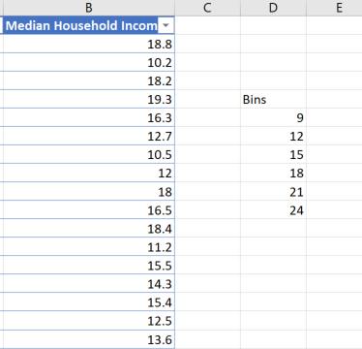

*Now, go to the data tab, and click on Data Analysis Tools.*

*Click Histogram and the following dialog box will appear:*

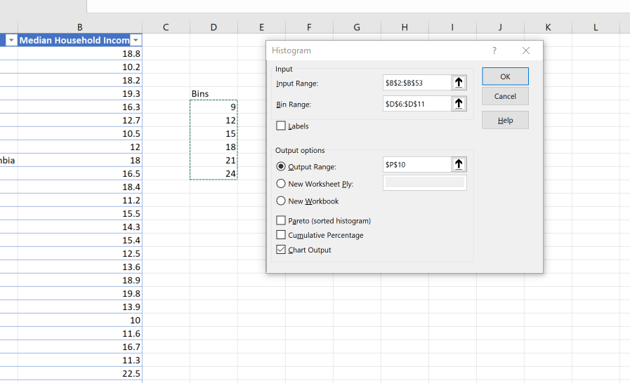

*Select the income data for the input range (no need to include the label, unless you want it)*

*Select your Bins for the Bin*

*Select some empty space on your spreadsheet for the output range*

*Click the Chart Output box*

*Click OK*

And that is it. You now have a histogram 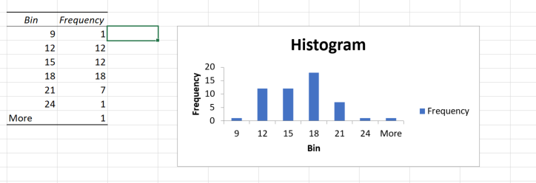

**Sampling**

The Data Analysis tools make it super simple to get samples from a population. Although this is a very small amount of data (51 data points), you can imagine if you were doing research on a data set with hundreds, thousands, tens of thousands, etc. of data points. Getting a random sample from such a large dataset is not that easy. So even though this is a trivial example, it is good to know how it is done.

*Choose Data Analysis Tools from the Data tab*

*Choose Sampling.*

*Give it the input range of state data*

*Tell it how big your sample size should be in Number of Samples. Try 5*

*Tell it where you want it to show the output*

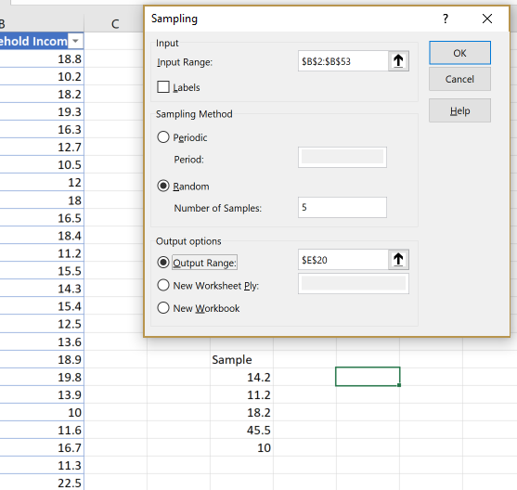

Now you have your sample, with no complex formula, no macros, and no repetitive operations required.

Where to go from here

This course has barely scratched the surface both in terms of the useful data provided by US Census and the tools in Excel that you can use to work with that data. We explored just a few data sets and a few ways to use it. However, the use cases are almost limitless. Here are just a few examples of how data from the Census Bureau are used:

* Decision making at all levels of government.
* Forecasting future transportation needs for all segments of the population.
* Planning for hospitals, nursing homes, clinics and the locations of other health services as well as for distributing medical research.
* Designing public safety strategies and creating maps to speed emergency services to households in need of assistance.
* Planning health and educational services for people with disabilities.
* Attracting new businesses to state and local areas.
* Planning for school construction and other projects.

Further, Census provides a myriad of tools for finding the data that you need, accessing it with a variety of applications and devices, and incorporating it into research and other data-heavy activities. Go to <http://census.gov> to discover more.

Excel provides numerous easy to use tools for taking that data and combining it with other data, manipulating the data through formulae and functions, visualizing the data, pivoting it to understand the data in new ways, and sharing the data with a large number of other data sources and stores. It provides ways to help users not only gain insights from the data, but also to collaborate on it. I hope that this course has inspired you to explore further on your own.